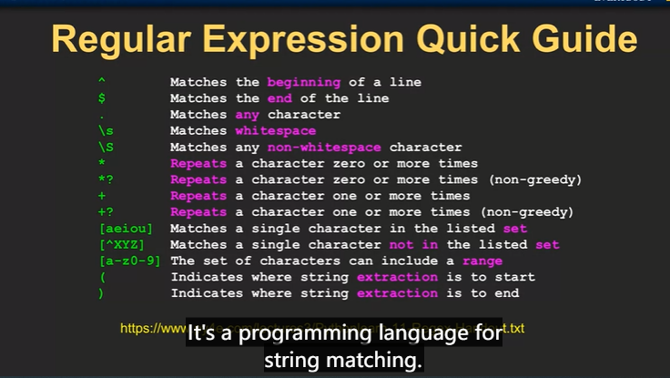

re.search
re.findall() any portion
nomal: largest string
?:not greedy-shorter string

